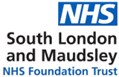

Thinking about Autism?
The 3 Borough Adult ADHD and Autism Service (3B) helps adults who are registered with a GP in Croydon, Lambeth and Lewisham, explore whether they may be autistic or have ADHD.

This service is part of South London and Maudsley NHS Foundation Trust (SLaM).

We recognise that autism is often missed or misunderstood in culturally diverse and minoritised communities. We are committed to addressing this by improving access, communication and trust.
If y ou need this leaflet in different format (such as audio) or another language, please contact us at 3Breferrals@slam.nhs.uk. We will do our best to help you.

What is Autism?
Autism is a neuro-developmental condition.
A neurodevelopmental condition is something:
you are born with, or
it starts when you are very young
Autistic people may:
find talking to others and navigating social situations hard
prefer to do things in the same way
have strong interests in certain topics or activities
Autism can look different for each person. Things like culture, gender, or past experiences can all shape how autism is experienced and understood. There’s no one way to be autistic - and that’s okay.


The National Autistic Society (NAS) has lots of helpful information about autistic adults, including how to request a referral and what support may be available. Scan the QR code or visit their website: www.autism.org.uk

How to get a referral.
Speak to your GP first.
Your GP may ask you some questions about:
your relationships with others
what you were like as a child and at school
your daily routines
if you have any sensitivities (like to noise or touch)
what things you are interested in.
Your GP may refer you to the 3B service for assessment.
The 3B team might contact you to ask a few more questions. If we think another service would help you more, we may refer you there instead.
The questions we, or the GP ask, are to help us better understand your experience. There are no right or wrong way to respond. Share what feel is true to you.
We understand that some people may have felt unheard when sharing their concerns. Everyone has the right to request a referral for an autism assessment. If you are unsure how to begin this conversation with your GP, this leaflet can help guide you.

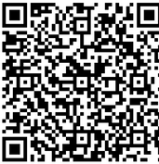
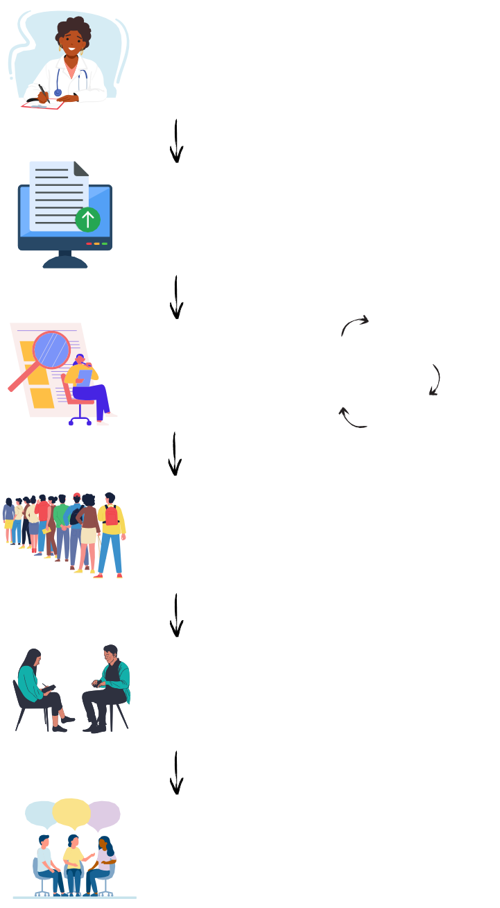
What happens if your referral is accepted?
Getting support: what
the journey looks like
Speak to your GP
about making a referral for an autism assessment
GP sends
referral to 3B

Referral reviewed by 3B clinician
3B or GP may
contact you for more information
If referral is
accepted, you’ll be added to the 3B waitlist
Information
received and added to waiting list
You will then
have your assessment
Outcome and
support
If your referral is accepted, you’ll be added to the 3B waiting list.
We will send you a letter to let you know.
You will also receive a ‘Whilst You Wait’ guide. This explains what to expect w hile you are waiting for your assessment.
Many people wait for some time for an assessment. We recognise that waiting for an assessment can feel difficult, frustrating or isolating. You are not alone, and we hope the resources we give whilst you wait help.
If you would like to see how long our wait list is at the moment, please visit our website below.
3B Website
During the assessment, it helps to speak with someone (such as a parent) who knew you well as a child, to understand if these traits have always been a part of your life.
If there is no one who can share information about your childhood, that’s okay. We can still do your assessment.

For more information of if you have any questions, please get in contact with us by email or phone.

Contact us
3Breferrals@slam.nhs.uk 020 3228 8469
Support
To find out more about support available without a diagnosis of autism, please visit the websites below.
Croydon Autism Service www.croydon.gov.uk/active-lives-day-and-evening- support/croydon-autism-service
Lewisham Autism Hub www.resourcesforautism.org.uk/lewishamautismhub/ Lambeth Autism Group
www.autism.org.uk/what-we-do/branches/lambeth
Inaspectrum: Support Group (Croydon)
www.inaspectrum.com/
Enna - Neurodivergent Recrutiment Service
www.enna.org/
Exceptional Individuals (employment support)
www.exceptionalindividuals.com/
acas working for everyone (employment support)
www.acas.org.uk/reasonable-adjustments LGBTIA+ Atypiqueers social group www.londonfriend.org.uk/london-friend-groups/
This leaflet was created with help from people who have lived experience of autism and using assessment services. We will keep reviewing and updating this leaflet over time. If you have any suggestions or if something doesn’t feel helpful, please let us know. You can share your thoughts by scanning the QR code below to fill in our short feedback form or email 3Breferrals@slam.nhs.uk.

