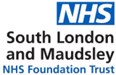

Thinking about ADHD?
The 3 Borough Adult ADHD and Autism Service (3B) helps adults who are registered with a GP in Croydon, Lambeth and Lewisham, explore whether they may be autistic or have ADHD.

This service is part of South London and Maudsley NHS Foundation Trust (SLaM).

We recognise that ADHD is often missed or misunderstood in culturally diverse and minoritised communities. We are committed to addressing this by improving access, communication and trust.
If you need this leaflet in a different format (such as audio) or another language, please contact us at 3Breferrals@slam.nhs.uk. We will do our best to help you.

What is ADHD?
Attention Deficit Hyperactivity Disorder (ADHD) is a neuro-developmental condition.
A neurodevelopmental condition is something:
you are born with, or
it starts when you are very young ADHD means there are differences in how the brain regulates attention and energy, which may look like:
finding it hard to concentrate
feeling restless and struggling to sit still
saying or doing things without thinking about the consequences first
ADHD can look different for each person. Things like culture, gender, or past experiences can all shape how ADHD is experienced and understood. ADHD can look different for everyone - and that’s okay.
We understand that some people may have felt unheard when sharing their concerns. Everyone has the right to request a referral for an ADHD assessment. If you’re unsure how to begin this conversation with your GP, this leaflet can help guide you.

How to get a referral
Speak to your GP first. Your GP may then ask you some questions about your experiences during childhood (ages 5-12) and adulthood, such as:
how well you could focus, both in school and later in life
whether you were often restless or found it hard to sit still
if you acted on impulse, such as interrupting others or finding it difficult to wait
when you first noticed these difficulties, and how they affected different areas of your life
Your GP may refer you to the 3B service.
Once we get the referral, our team will look at the information. We might contact you to ask a few more questions. If we think another service would help you more, we may refer you there instead.
The questions we, or the GP ask, are to help us better understand your experience. There are no right or wrong ways to respond - share what feels true to you.

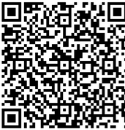
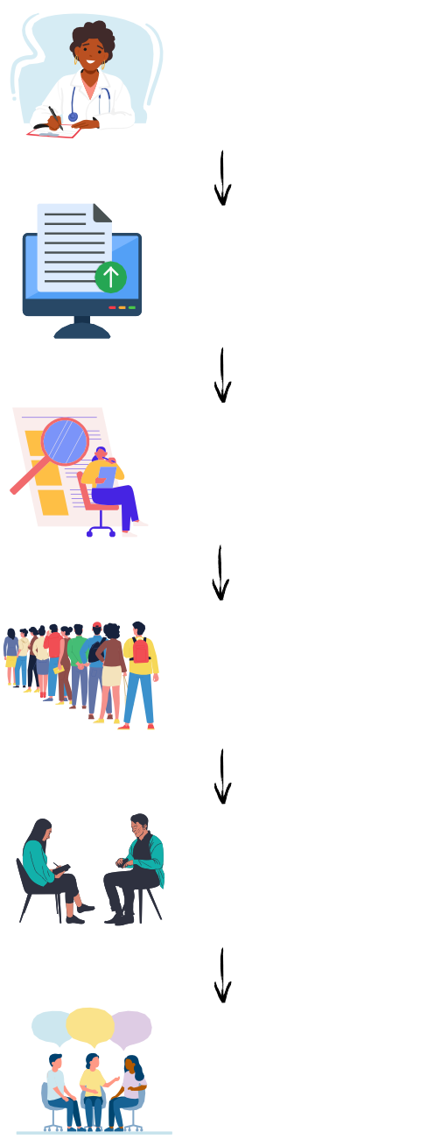
What happens if your referral is accepted?
Getting support: what
the journey looks like
Speak to your GP about making a referral for an ADHD assessment
GP sends
referral to ADHD triage centre
Referral
reviewed by ADHD Triage Centre
If referral is
accepted, you’ll be added to the 3B waitlist
You will then
have your assessment
Outcome and
support
If your referral is accepted, you’ll be added to the 3B waiting list.
We’ll send you a letter to let you know.
You’ll also receive a ‘Whilst You Wait’ guide - which explains what to expect while you’re waiting for your assessment.
Many people wait for some time for an assessment. We recognise that waiting for an assessment can feel difficult, frustrating or isolating. You are not alone, and we hope the resources we give whilst you wait help.

If you would like to see how long our wait list is at the moment, please visit our website below.
3B Website
During the assessment, it can help to speak with someone (such as a parent) who knew you well as a child to understand if these traits have always been a part of your life.
If there is no one who can share information about your childhood, that’s okay. We can still do your assessment.

For more information of if you have any questions, please get in contact with us by email or phone.

Contact us
3Breferrals@slam.nhs.uk 020 3228 8469
Support
To find out more about support available without a diagnosis of ADHD, please visit the websites below.
ADHD-NHS
www.nhs.uk/conditions/attention-deficit-hyperactivity- disorder-adhd/
ADHD UK
www.adhduk.co.uk/about-us/
ADHD Foundation
www.adhdfoundation.org.uk
ADHD Babes (community group for black women and non-binary people with ADHD) www.adhdbabes.com/about-us
LGBTIA+ Atypiqueers social group
www.londonfriend.org.uk/london-friend-groups/
acas working for everyone (employment support)
www.acas.org.uk/reasonable-adjustments
Enna - Neurodivergent Recrutiment Service
www.enna.org/
Exceptional Individuals (employment support)
www.exceptionalindividuals.com/
This leaflet was created with help from people who have lived experience of ADHD and using assessment services. We will keep reviewing and updating this leaflet over time. If you have any suggestions or if something doesn’t feel helpful, please let us know. You can share your thoughts by scanning the QR code below to fill in our short feedback form or email 3Breferrals@slam.nhs.uk.

